IT241024546

Abeygunasekera P

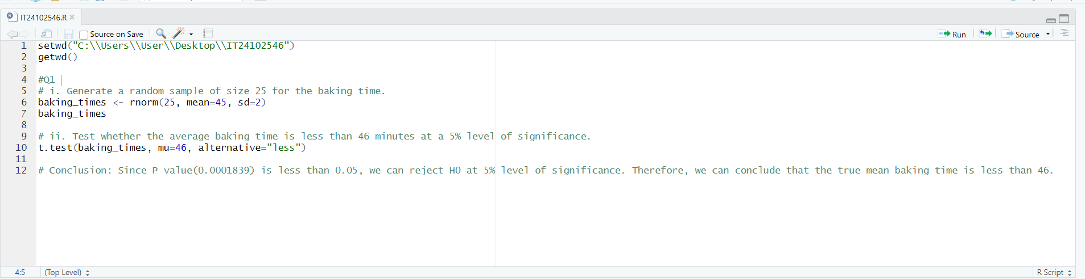PS Lab sheet 9

